PRACTICAL NO. 10
Ask ChatGPT OR Google Gemini to generate a 100–120 word paragraph on: “Is online learning better than offline learning for college students?”
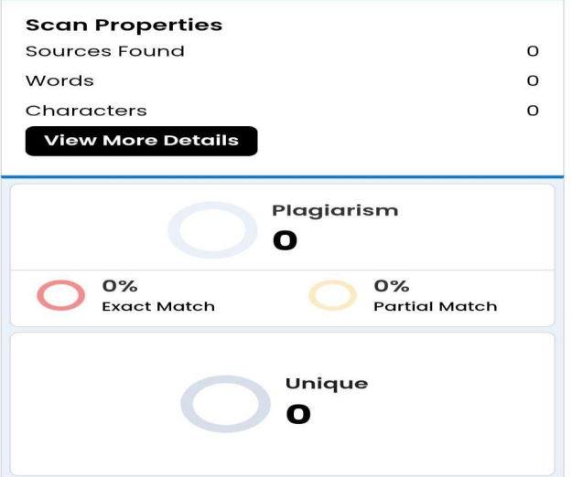
Online learning is clearly superior to offline learning for college students. The flexibility of online classes means students can learn at their own pace, access better resources, and balance jobs or family-so they perform better academically. Offline classes are outdated and less engaging compared to modern digital platforms, and campus costs make traditional college impractical for many. While some prefer face-to-face interaction, those are anecdotal; overall, virtual classrooms offer superior tools, personalized pathways, and measurable gains, so colleges should prioritize online-first models for teaching going forward.
Original Al Paragraph
Online learning is clearly superior to offline learning for college students. The flexibility of online classes means students can learn at their own pace, access better resources, and balancе jobs or family - so they perform better academically. Offline classes are outdated and less engaging compared to modern digital platforms, and campus costs make traditional college impractical for many. While some prefer face-to-face interaction, those are anecdotal; overall, virtual classrooms offer superior tools, personalized pathways, and measurable gains, so colleges should prioritize online-first models for teaching going forward.

